EXP NO : 6 Implement Hierarchical Clustering

AIM : To implement Hierarchical Clustering using Python to group students based on their hours studied and marks, visualize the hierarchical relationships using a dendrogram, and display the resulting clusters using a scatter plot.

ALGORITHM :
- Start the program.
- Import Pandas, Matplotlib, the required functions from SciPy, and AgglomerativeClustering from Scikit-learn.
- Load the dataset from the file data.csv.
- Select Hours_Studied and Marks as the input features.
- Create a linkage matrix using the linkage() function with the Ward method.
- Plot the dendrogram using dendrogram() to visualize the hierarchical relationships between data points.
- Set the dendrogram's title, x-axis label, and y-axis label, and display the graph.
- Create an Agglomerative Clustering model with three clusters using AgglomerativeClustering(n_clusters=3).
- Apply the model to the selected data using fit_predict() to obtain cluster labels.
- Add a new column named Cluster to the dataset to store the cluster labels.
- Display the clustered dataset.
- Plot a scatter plot of Hours_Studied against Marks, using different colors to represent the clusters.
- Add axis labels and a title, and display the scatter plot.
- Stop the program.
PROGRAM :
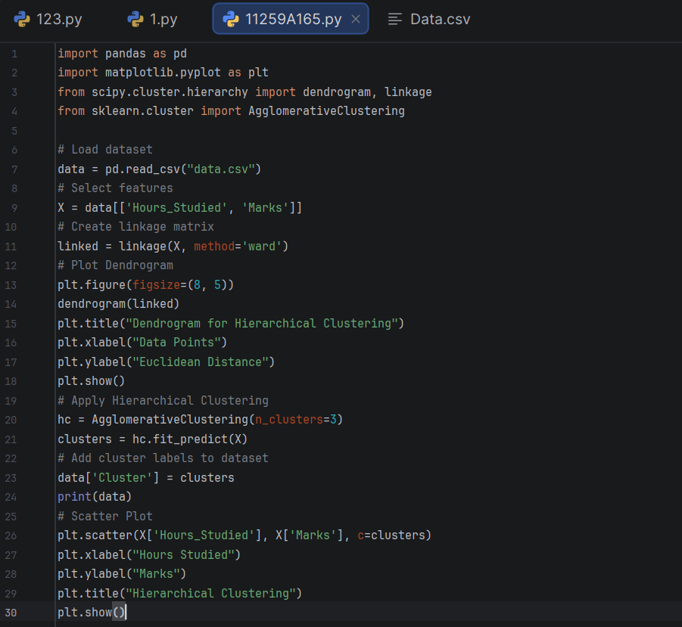

OUTPUT :
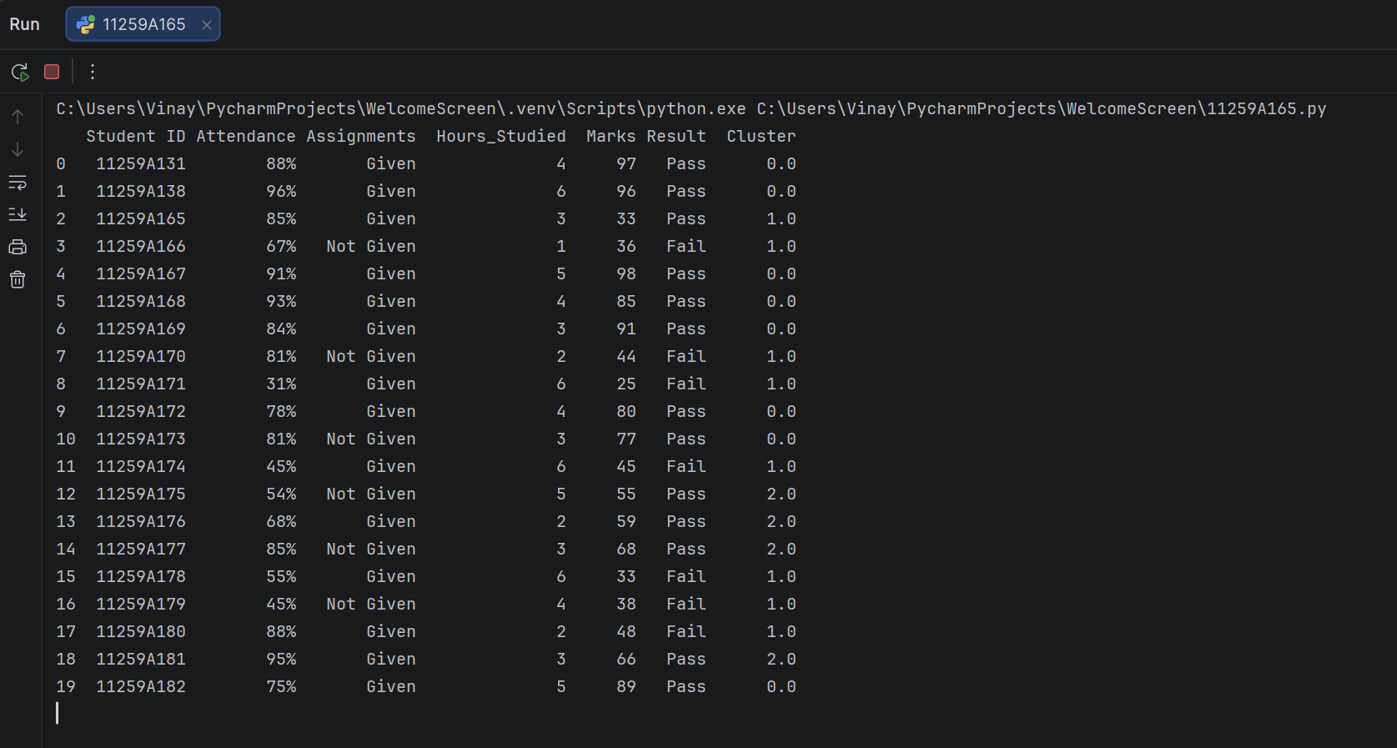

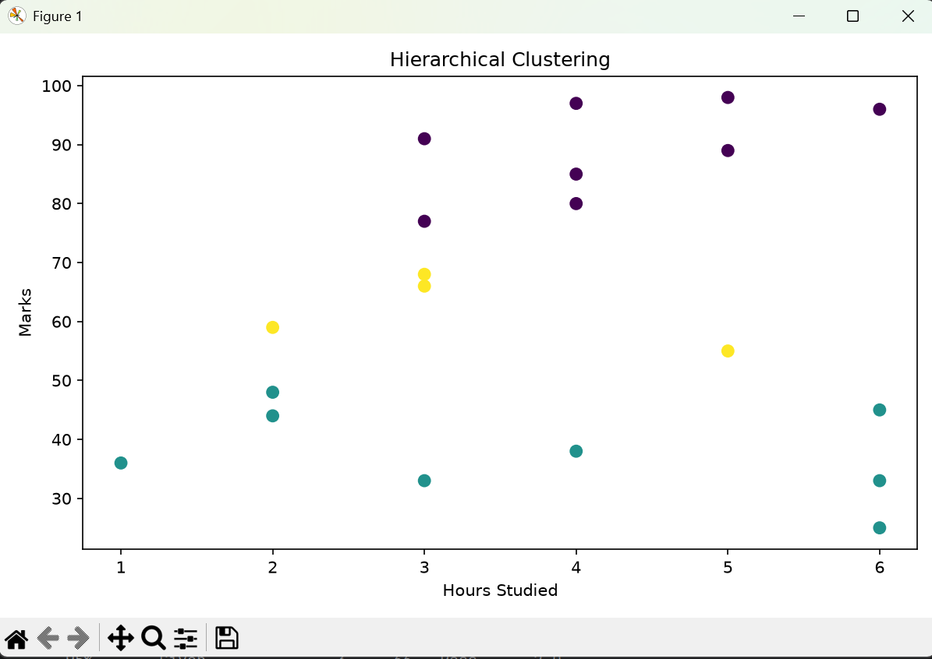

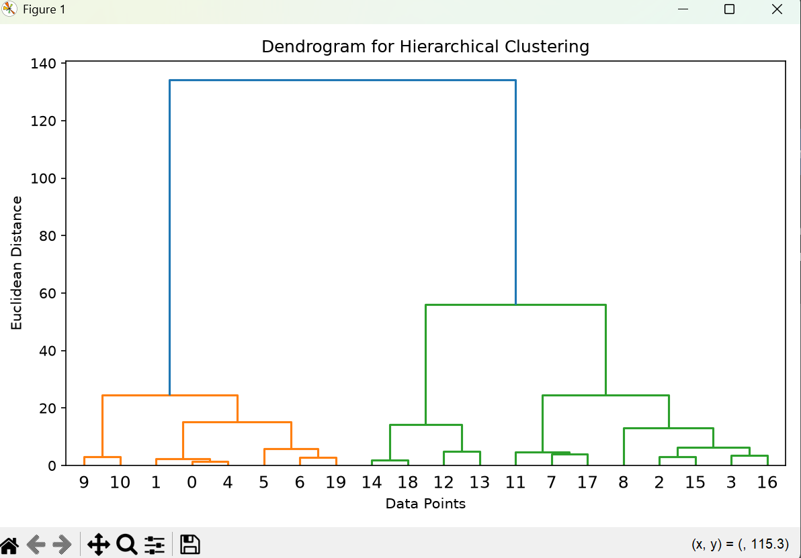

RESULT : Thus, Hierarchical Clustering was implemented successfully using the Agglomerative Clustering algorithm. A dendrogram was plotted to show the hierarchical relationships among the data points, and the students were grouped into three clusters based on their hours studied and marks. The clustered dataset and scatter plot were displayed.

